**Installing New Software**

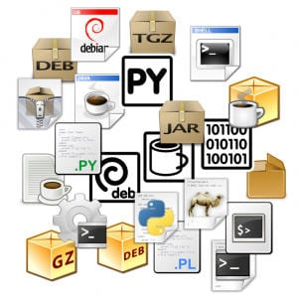

* Most people are surprised to see that they have a running, usable computer after installing Linux; most distributions contain ample(bol) support for video and network cards, monitors and other external devices, so there is usually no need to install extra drivers. Also common tools such as office suites, web browsers, Email and other network client programs are included in the main distributions. Even so, an initial installation might not meet your requirements.
* If you just can't find what you need, maybe it is not installed on your system. It may also be that you have the required software, but it does not do what it is supposed to do. Remember that Linux moves fast, and software improves on a daily basis. Don't waste your time troubleshooting problems that might already be resolved.
* You can update your system or add packages to it at any time you want. Most software comes in packages. Extra software may be found on your installation CDs or on the Internet. The website of your Linux distribution is a good place to start looking for additional software and contains instructions about how to install it on your type of Linux.

**Package Management**

**Package formats**

* **RPM packages:** RPM, the RedHat Package Manager, is a powerful package manager that you can use to install, update and remove packages.
* **DEB (.deb) packages:** This package format is the default on Debian GNU/Linux, where dselect, and, nowadays more common, aptitude, is the standard tool for managing the packages.
* **Source packages:** The largest part of Linux programs is Free/Open Source, so source packages are available for these programs.

**Package Management**

* The first thing you do after installing a new system is applying updates; this applies to all operating systems and Linux is not different.
* The updates for most Linux systems can usually be found on a nearby site mirroring your distribution

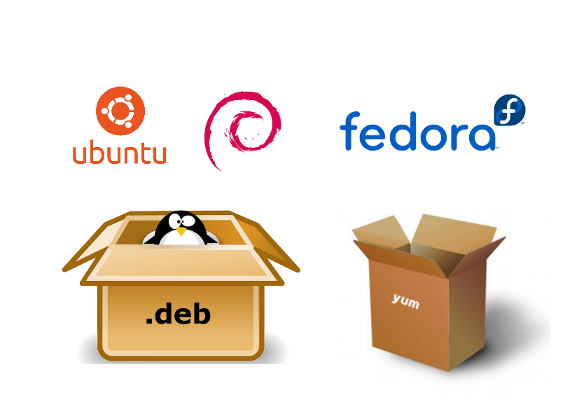

* Most Linux distributions have a package management system with online repositories containing thousands of packages. This makes it very easy to install and remove applications, operating system components, documentation and much more.

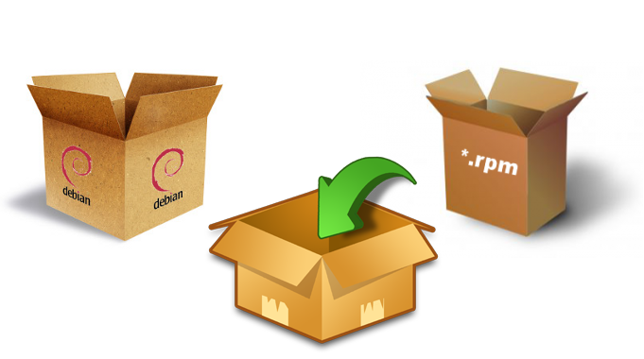

* We first discuss the Debian package format .deb and its tools dpkg, apt-get and aptitude. This should be similar on Debian, Ubuntu, Mint and all derived distributions.

**Package Terminology**

**Repository**

A lot of software and documentation for your Linux distribution is available as packages in one or more centrally distributed repositories. These packages in such a repository are tested and very easy to install (or remove) with a graphical or command line installer.

**.deb Packages**

Debian, Ubuntu, Mint and all derivatives from Debian and Ubuntu use .deb packages. To manage software on these systems, you can use aptitude or apt-get, both these tools are a front end for dpkg

**.rpm Packages**

Red Hat, Fedora, CentOS, OpenSUSE, Mandriva, Red Flag and others use .rpm packages. The tools to manage software packages on these systems are yum and rpm.

**dependency**

Some packages need other packages to function. Tools like apt-get, aptitude and yum will install all dependencies you need. When using dpkg or rpm, or when building from source, you will need to install dependencies yourself.

**Open Source**

These repositories contain a lot of independent open source software. Often the source code is customized to integrate better with your distribution. Most distributions also offer this modified source code as a package in one or more source repositories.

**Popular Linux System Package Managers**

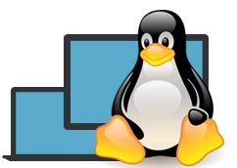Formun Üstü

Formun Altı

Linux systems use package managers to add or remove the software packages. Actually, these package managers are also a package so you can install any of them. It is important to understand fully how Linux handles packages. In this lesson, we will handle the default package managers of the famous Linux distributions.

**Q:** What does package managers?  
**A:** A package manager or package-management system is a collection of software tools that automates the process of installing, upgrading, configuring, and removing computer programs for a computer's operating system in a consistent manner.

 - Interview Q&A

**DPKG – Debian Package Management System-1**

Dpkg is the main package management program for the Debian Linux distros. It is used to handle Debian package files with the extension of **.deb**

**dpkg** is a low-level command that can be invoked with many options.

$ dpkg –help # Listing all options

**APT (Advanced Package Tool)**

| **apt-get & apt-cache** | **apt-binary** |
| --- | --- |
| apt-get update | apt update |
| apt-get upgrade | apt upgrade |
| apt-get dist-upgrade | apt full-upgrade |
| apt-get install package | apt install package |
| apt-get remove package | apt remove package |
| apt-get autoremove | apt autoremove |
| apt-cache search string | apt search string |
| apt-cache policy package | apt list -a package |
| apt-cache show package | apt show package |
| apt-cache showpkg package | apt show -a package |

It is a free and advanced interface to the Debian packaging system. It provides tools for managing packages and low-level access to all features of the libapt-pkg library.

Starting with Debian Jessie, some frequently used **apt-get** and **apt-cache** commands have an equivalent via the new apt binary.

The apt tool gets the ability of apt-get and apt-cache. It has a colored output format. But in scripts or advanced use cases, apt-get is still preferable or needed.

$ apt update # Updating the list of packages known by your system

$ apt install # Installing a package and all its dependencies

$ apt remove #Removing a package

$ apt purge # Removing a package and its configuration files from your system

**DPKG – Debian Package Management System-2**

**Aptitude Package Manager**

**aptitude** is a package manager for Debian Linux systems that performs action from the visual interface and from the command-line. aptitude can be used to perform management tasks in a fast and easy way.

**aptitude** tool provides the functionality of **apt-get**, as well as many additional features:

* aptitude provides easy access to all versions of a package.
* aptitude tracks of obsolete(modası geçmiş) software.
* aptitude has a powerful system for searching particular packages

The command-line syntax used is very similar to the one used in **apt-get**.

$ aptitude install # Installing a package

**Synaptic Package Manager**

Synaptic is a graphical package manager and used for installing, upgrading and removing single and multiple packages in a more user-friendly way. It can be used in most of the linux distributions.

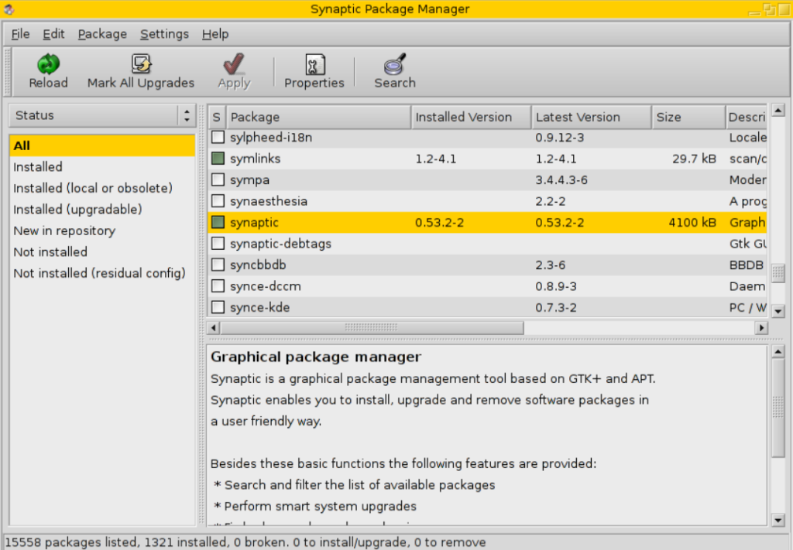

**Other Debian Tools**

**dpkg-deb**

This program manipulates Debian archive (.deb) files.

$ dpkg-deb –help # Listing all the options

**Q:** What is the difference between dpkg and aptitude/apt-get?  
**A:** **dpkg** only installs a package, so doing dpkg -i packageName.deb will only install this Deb package, and will notify you of any dependencies that need to be installed, but it will not install them, and it will not configure the packageName.deb because well...the dependencies are not there.  
  
**apt-get** is a Package Management System that handles the installation of Deb packages on Debian-based Linux distributions. A Package Management System is a set of tools that will help you install, remove, and change packages easily. So apt-get is like a clever dpkg.

 - Interview Q&A

**RPM (Red Hat Package Manager)**

RPM, created by Redhat, is a free and open-source package management system for Red Hat Linux operating systems. The installation package files have **.rpm** extension. These files are used for installing programs. **rpm** command has been used for RPM packages by default but new tools are developed for better performance.

**YUM (Yellowdog Updater Modified)**

YUM is an open-source package manager that was developed by Duke University. It is used both in the command line and GUI. It supports numerous repositories. It works mostly the same as APT in Debian Linux systems. Here are some examples of YUM.

$ yum install # Installing a package

$ yum -y install # During installment, linux asks for confirmation. To skip confirmation you can use option -y.

$ yum remove # Removing a package with all dependencies.

$ yum update # Updating a package

**DNF – Dandified Yum**

It is the new generation of YUM package manager. It is the default package manager of Fedora 22 and newer distros. YUM has a bad reputation for memory usage and poor performance when resolving dependencies. So it is replaced by DNF. The usage of DNF is mostly the same as YUM.

$ yum install epel-release -y

$ yum install dnf #If you don’t have DNF, you can install it via yum.

$ dnf –version # Checking DNF version

$ dnf install # Installing a package

**Other RPM tools:**

* zypper (openSUSE)
* up2date (Red Hat Enterprise Linux, CentOS 3 and 4, and Oracle Linux)
* urpmi (Mandriva Linux, ROSA Linux, and Mageia
* apt-rpm (Ark Linux,[11] PCLinuxOS and ALT Linux)
* smart (Unity Linux and Fedora)
* rpmquery (Red Hat Enterprise Linux)

**Other Package Managers**

Below are a few more notable/interesting package managers.

* Portage: Package manager for Gentoo.
* Pacman: Arch Linux Package manager.
* Nix: A ‘Fully Functional/Transactional’ package manager.
* Brew: An Open Source package manager for OSX.
* Chocolatey: A package manager for Windows.

**💡Tips:**

* Programming languages have their own default package managers. They help to find and install the packages via searching libraries that exist on the internet for that language. Examples:
* Python: pip
* Ruby: gem, rubygems
* Haskell: cabal
* NodeJS: npm

Complementary Lesson about Using Package Managers :

<https://youtu.be/bwOp46xAmkM>

Complementary Lesson about Using Package Managers :

<https://youtu.be/AKUCuTmyltQ>